**CHILD CARE AND YOUTH EMPOWERMENT FOUNDATION (CCAYEF)**

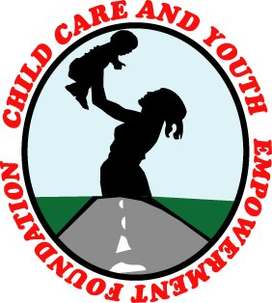

**CCAYEF QUARTER 1 REPORT 2018**

**Background**

Child Care and Youth Empowerment Foundation (CCAYEF) is a registered Non- government, non-political, non-religious and not for profit Organization that was founded in January 2008 as a Community Based Organization (CBO), with a mission to improve the well-being of children, youth and young women, and mitigate the effects of the challenges they encounter. The founding members where professionals with different backgrounds but interfacing with children, youth and women in vulnerable states. Children constitute the majority of Ugandans and some of the children are youth. Hence, these are the primary beneficiaries of our interventions.

Our mandate covers the four districts of Mukono, Kayunga, Buvuma, and Buikwe. Delivery of our service packages is guided by our mission, vision, values and strategic objectives.

**Vision:** CCAYEF envisions a world of well nurtured children, empowered youths, and communities committed to social justice and peace.

**Mission:** Improving the well-being of vulnerable children and youth through education, socio-economic interventions, nutrition and health care.

**Values**: Social Justice, Empowerment, Love, Integrity and Professionalism.

**Introduction**

This report focuses on activities carried out in CCAYEF through its thematic areas; Adolescent Health and Empowerment, Orphans and other Vulnerable Children (OVC) and Early Pregnancy Prevention, Organizational Strengthening and Capacity building. Below are the activities carried out in 2017.

**PROGRAM AREA 1: ADOLESCENT HEALTH PROMOTION STRATEGY (AHES)**

The Adolescent Health Promotion Strategy (AHES) is a youth-focused thematic area under Child Care and Youth Empowerment Foundation (CCAYEF). This strategy addresses the needs of young people by building their capacities through trainings on life skills, leadership development, and Sexual and Reproductive Health (SRH) for both in and out of school youth. It realizes its goal through two projects namely; the Schools in Charge and the DREAMS projects implemented in Mukono municipality and Mukono district at large.

The major goal of this Strategy is to empower young people with knowledge and skills necessary for healthy development and self-reliance. All activities within the two projects implemented under this strategy are geared towards this goal.

1. **The Schools in Charge (SiC) Project:**

This is a school Based intervention towards prevention of adolescent pregnancy, child marriages and HIV/AIDS among in school adolescents in Mukono District. This on-going project was designed to build the knowledge gap within in-school adolescents and to change the attitudes of teachers, parents and students on sexual reproductive health information and services, and to support them acquire skills of passing on the same information to all adolescents under their mandate in prevention of HIV/AIDS infections, adolescent pregnancies and other results of high risk sexual behaviors.

This activities carried out under the SiC project are intended to achieve the following objectives;

• Increase the knowledge and awareness on the associated risks of early sexual debut and unprotected sex among adolescents by 20% by December 2019.

• Train 100 peer educators from 4 secondary schools in Mukono district in SRH, life skills, and adolescent counseling every year.

• Over 1500 secondary school students in Mukono district trained on SRH through peer to peer counseling done by trained peer educators by December 2016.

• Train 40 secondary school teachers in Mukono district in Adolescent Counseling and SRH services by December 2016.

• 100 parents in Mukono district with students in the four selected schools sensitized on Adolescent counseling and the importance of Adolescent Sexual Reproductive Health to their children.

**What we planned to achieve under the SiC Project!**

In the year under review, we planned to train 4 Peer Health Clubs in four secondary schools of Mukono Municipality, Mukono district, Train secondary school teachers in adolescent sexual reproductive health and adolescent counseling skills, Sensitize parents in the four schools, print IEC materials for the schools, Reaching out to other young people with SRH information, evaluation and monitoring of project performance. This report is an account of the achievements and details are found in the subsequent pages.

1. **Establishment and training of 4 Peer Health Clubs**

This is one of the core interventions under the SIC program for the department through which adolescents/ young people across Mukono District are reached with appropriate Sexual and Reproductive Health services and information and empowered through Life Skills training. This program was first introduced to schools in 2014 operating in 4 pioneer clubs which increased to 11 clubs to date. During the year 2017 however we were unable to work with all the four planned Clubs due to financial constraints. Only one club was established in one school with 30 members. Training sessions were always conducted on a weekly basis at St. Francis SS Borgia High School.

**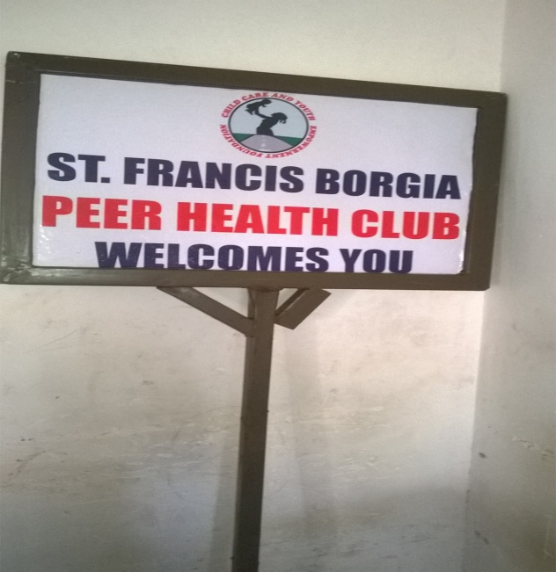*Sign post for PHC of St. Francis Borgia High School***

***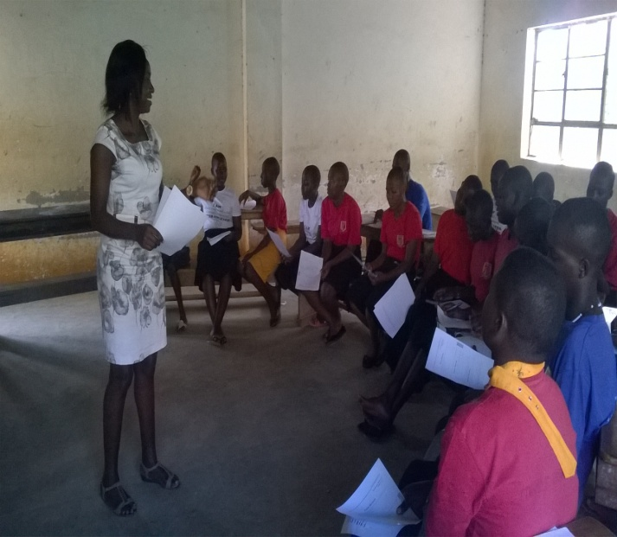***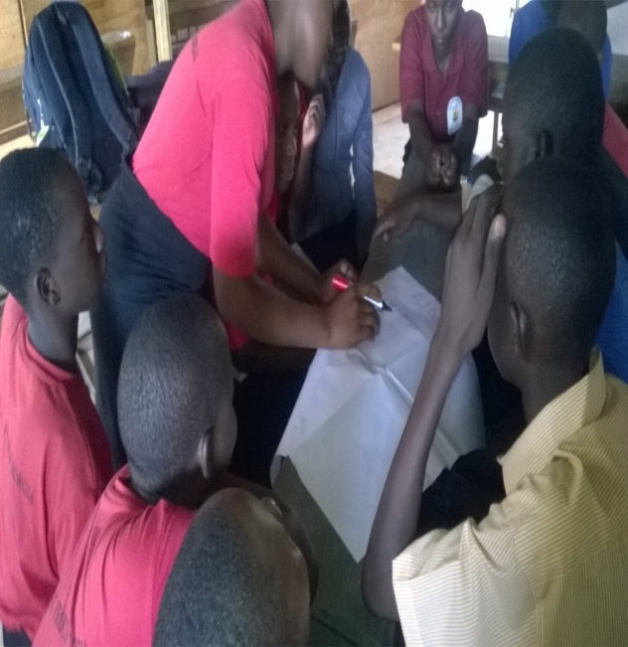***PHC members during training sessions***

**Peer Health Club Activities:**

* The club reached 1,473 young people with various information on adolescent sexual and reproductive health services through the trained peer educators.
* Several participatory health education and young people engagements were done through peer provided services, open in school SRH dialogues and IEC materials on ASRH, which increased young people and general school community knowledge and awareness of ASRH, positively influenced students- teacher relations; improved ASRH knowledge and rights awareness.
* Life skills were taught to the adolescents that improved their communication and decision-making ability, which led to greater self-esteem, self-efficacy, social skills, decision-making and self-confidence among adolescents. 5 of the club members took crucial leadership positions on the school electorate body including the highest office of Head prefect. They became empowered and developed a sense of accountability to seek out their own health care, and to make better choices regarding their reproductive health. Students learnt to seek for health services from rightful sources.
* Overall, the project led to greater support from the school community and working through collaboration with all the school departments and teachers.
* Developed and produced 4 training manuals on ASRH to facilitate more learning about ASRH.
* The club elected 12 leaders democratically to act as a link between the club members and the patron.
* The club was supported and facilitated with stationery to effectively deliver ASRHs, Life and Counseling skills to the larger school community. 5 files were procured and given to club leaders to promote the culture of proper record management/ keeping.

1. **The teacher Training sessions in ASRH:**

According to the design of this project, teachers, administrators and support staff in the school of implementation are trained at the very beginning of the project with an aim of equipping them with the skills they need to sensitize their students on ASRHR and to be able to boldly answer questions posed to them by students and peer healthy educators in their respective schools. In the year under review, ………… teachers were trained and students have reported having counseling sessions with their teacher.

A photo of a teacher training session

1. **Parents’ sensitization sessions:**

This activity is intended to support parents change their attitudes towards information concerning adolescent sexual reproductive health and build their esteem towards giving it to their children. ……. Parents were sensitized and a good number of them have been reported to having talked to their children about their sexuality.

1. **Designing and Printing of IEC materials:**

We planned to design different IEC materials that bear information on teenage pregnancy prevention, HIV and other STDs, however due to money constraints only 30 Club T-shirts and 30 name tags were printed and distributed to 30 club members. This improved their identity and visibility.

1. **Examining the Project Results:**

A pre-test is exercised to both students and teachers before the trainings start, and a post test is given at the end of this project implementation in a period of one year. In 2017, the results from comparison of both tests show that:

* The project registered progress in terms of numbers of young people reached, change in knowledge and attitudes. Additionally, there was an increase from **31%** to **58%** in the understanding of what life skills are and their relevance.
* There has been a **13%** increase since our intervention from to **78%** in the number of young people with increased knowledge of health risks associated with unprotected sex compared to **65%** reported in the baseline. This can partly be attributed to our interventions in the school.
* Relatedly, a significant percentage change (83%) in the number of young people in the targeted school with increased knowledge on the safer sex practices.
* 12% increase from **74%** to **86%** in the number of young people who feel confident in their ability to resist pressure and delay sex.
* Findings further reveals a 16% increase in knowledge concerning life skills and ASRH among school non club members.
* A total number of 973 (579 females and 394 males) students were sensitized through health talk, visual and film show. These were sensitized on HIV/ AIDS, drug abuse, teenage pregnancy and abortion among young people.

1. **Reaching out to other young people with SRH Information:**

Sexual Reproductive Health is one of the aspects that cannot be ignored if one is to achieve the goal of increasing the productivity of young people. Although most young people in Uganda have heard about many aspects of Sexual and reproductive health, few have detailed knowledge and access to such services. Several reports over time have indicated that ASRH issues are rarely discussed between parents/ guardians and their children. In an effort to enhance knowledge among young people in relation to SRH, CCAYEF through the Adolescent Health Promotion Strategy, embarked on awareness campaign in collaboration with secondary schools of Mukono district and beyond. This program is a replica of Schools in Charge program and it offers opportunity to adolescents in schools outside Mukono municipality in form of consultancy services, as a way to fundraise for the smooth running of the SiC project activities. Talks on reproductive health, drug abuse, life skills and styles, have been done in several schools not just for the benefit of our targeted beneficiaries but also to contribute to the world of healthy and empowered youth and communities. These services were offered to schools such as, Kamuli PTC- Kamuli district, P/S, St. Joseph S.S. Namagunga and Naddunga S.S.

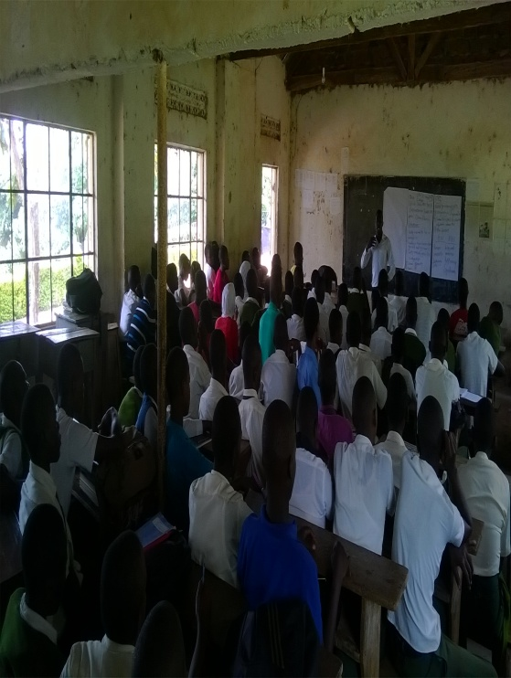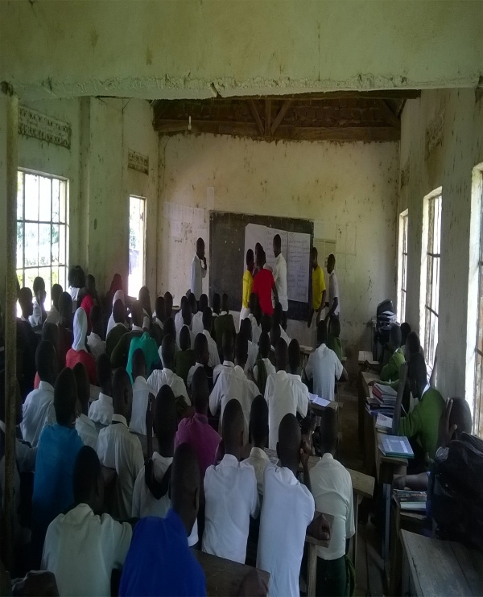***ASRH sensitization at Naddunga SS, Nakifuma- Kimmenyedde Sub-county***

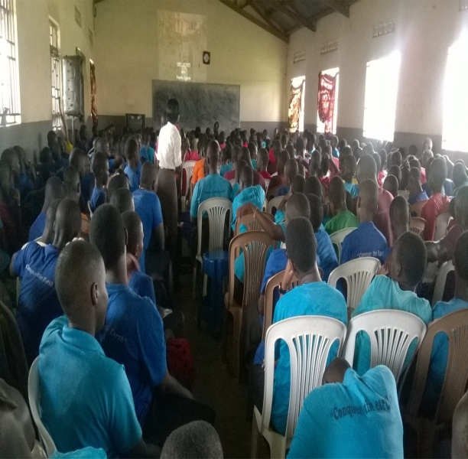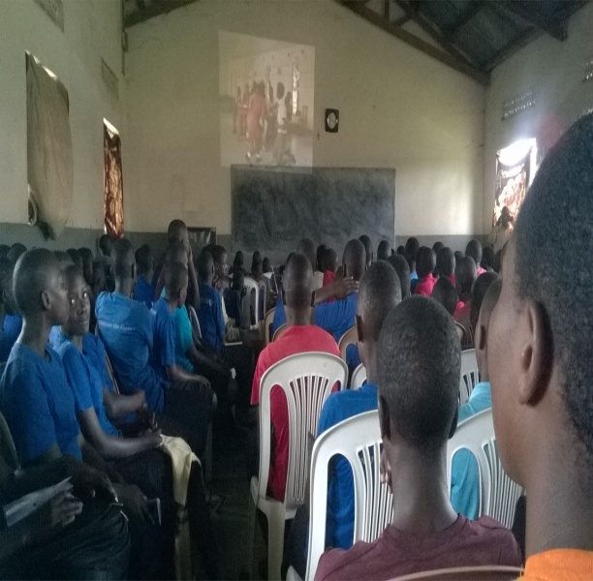***Students at St. Joseph SS Namagunga during ASRH sensitization***

During the process of implementation of the above outreaches to several schools 850 pieces of IEC materials containing various educative messages provided to young people and students to enhance their understanding of SRH with an aim of improving on SRH behaviour, knowledge and attitude among adolescents. The same young people received Career guidance and counseling services; and a total of 64 (38 females and 26 males) all of which were from Kamuli Nursery and Primary teacher’s college – Kamuli district. Feedbackk that was gothered there and then and even after these outreaches from all stakeholders indicate that students benefitted a lot from the sensitizations. One young person, …… said that ……….. Put a put a testimo tes

1. **The DREAMS Project:**

Close to one and half years now, Child Care and Youth Empowerment Foundation (CCAYEF) has been working along with Makerere University Walter Reed Project (MUWRP) as a partner to implement the DREAMS project in central division, Mukono district targeting Adolescent Girls and Young Women (AGYW) between the ages of 15-24 years. This is a girl empowerment project aimed at keeping HIV negative girls negative in Mukono central division. The focus of the DREAMS project is to reduce the incidence of HIV/AIDS among adolescent girls and young women through addressing structural drivers and this is done through various activities such as behavioral change classes referred to as stepping stones, Parenting and care giver programs; OVC and SINOVUYO, HIV Counseling and Testing (HCT), GBV care, Economic strengthening programs to include; vocational skills, financial literacy training, individual and small group savings and loan associations (VISLA), improved Contraception Mix, Peer to peer psycho-social support , PrEP promotion for Key and Priority populations, Condom Promotion & Provision and School Based HIV Prevention.

The program managed to reach many young people with various services and registered huge success in the year under reporting. During this the year 2017, we got engaged in many activities under the project which include but not limited to; Enrollment of AGYW, Conducting stepping stones, Data cleaning, Condom promotion and provision, HCT services for KP, PP and general population, SINOVUYO, Economic strengthening for AGYWs i.e. vocational skills training, VSLA and financial literacy training and GBV.

In each of the above activities, enormous achievements have been registered along with some challenges during the year under reporting as highlighted below.

In the year under review, we planned to conduct 12 integrated HCT outreaches targeting 60 people each for KPs, PPs, and general population, 9 community dialogue meetings, establish and train 4 Peer Health Clubs, condom education and promotion, SINOVIYO activities for in school AGYW, 30 VSLA groups empowered/trained and facilitated, training of over 350 AGYWs in Social economic strengthening, increasing on the number of people with increased access to PREP and ART services, designing and printing of IEC materials. The entry point of any client into the the DREAMS Project is HIV counseling and testing.

|  |
| --- |
|  |
| It is intended to combat the spread of HIV infection. CCAYEF through the DREAMs project strengthened her efforts to ensure that adolescent girls and young women are empowered to establish their sero status and those found negative to remain negative while the positives to be empowered to live positively, linked to ART care and treatment and supported to adhere. These HCT services offered use different approaches namely; office/ center based HCT, facility based HCT done from Mukono HCIV and community outreach. This year, in partnership with MUWRP started providing comprehensive HIV care services to Key population (CSW), Priority population (PP) and HIV prevention services. During the last quarter of the year, community outreaches were modified to include MARPs categories of priority population (PP), Key Population (KP) and general population regardless of the years. Comprehensive HIV care services were provided to MARPs through outreach clinics including moonlight outreaches in hot spots and parking yards of long distance truck drivers. This is done under the new ministry guideline of ‘Test and Treat’ as another strategy to reduce on HIV incidence and increase on the number of HIV patients enrolled on ART. |
|  |
| E:\Adolescent health and empowerment\Osman\Pictures 2107\HCT\WP_20171205_12_34_58_Pro.jpg C:\Users\ASUS\AppData\Local\Microsoft\Windows\INetCache\Content.Word\WP_20171206_16_31_56_Pro.jpg  ***HCT services for KP, PP and general population***  E:\Adolescent health and empowerment\Osman\Pictures 2107\HCT\WP_20171206_14_00_40_Pro.jpg E:\Adolescent health and empowerment\Osman\Pictures 2107\HCT\WP_20171206_14_23_42_Pro.jpg |

**Figure 1. Numbers accessing HIV Testing and Counseling, 2017**

**Accomplishments of the DREAMS Project**

* 799 AYWG were trained and empowered to make better and sound career choices. These were sensitized on topics such as goal setting, caring for HIV/AIDs patients, gender based response among others.
* A total of 4,197 people were reached with HCT services. 1,838 are AGYW both in school and out of school, 1067 Priority Population, 1084 general population, 111 Key Population. Out of 3843 tested, 45 people reacted positively of whom 19 are already on treatment who wanted to repeat the test, 26 were linked to care but only 12 have been enrolled to ART care and treatment.
* Condom education and distribution. 1 condom outlet/ dispenser was established at CCAYEF offices. 31,038 condoms were distributed by the different program mentors/ peer educators to the community and adolescent girls and young women.
* 6 people are receiving Prep services.
* 8 VSLA groups that exhibited a great commitment and discipline towards saving, received booster grants. This sum of money is given to groups to add/ boost their already existing small scale investments. These include: Basooka kwavula; rental chairs, Agali awamu; poultry keeping, Arise and shine; piggery, Tugoba bwavu; making books, Makula; piggery, Winners; charcoal selling, United hands at work; piggery and Empowered; rental chairs.
* Over 180 adolescent Girls and Young Women completed and graduated in different vocational courses; hairdressing and salon, jewelry making, sweater knitting, tailoring and fashion designing and flower arrangement and decoration.
* 106 AGYW registered and sat for DIT exams and 280 AGYW sat for internal exams, 195 for Hair dressing, 77 for tailoring and 8 for sweater knitting of which 80% scored above average.
* Through VSLA; members in various saving groups developed a saving culture hence reduction their household expenditure on unplanned items.
* Opened up 3 safe spaces (training areas) for Adolescent Girls and Young Women) in Lweza, Ntawo and Kyungu to reach more young people with behavioral change and socio economic strengthening interventions in Mukono Municipality.

**Challenges**

* Due to limited resources, the club did not conduct both a club launch and a wrap up party at St. Francis Borgia High school.
* Due to other overriding school program, we unable to conduct teacher training in ASRH and Life skills training at St. Francis Borgia High School.
* Due to limitedness in resources, the program activities for this year were limited in only one school.
* The aspect of male involvement into the DREAMS project, is lacking, therefore in order to attract more girls into the project and manage retention male partner involvement should be looked into as an issue worthy touching.
* Mobilization of girls into the DREAMS project is a task that is much challenging as it comes with a lot of costs, yet it’s the only means girls can be reached, communities still luck the good will of mobilizing girls at a no cost.
* PREP services are hardly received by most of our clients we refer to Mukono HC IV; this has hampered our PREP score.
* Being confined in one geographical area reaching our services to the KP, PP in the dreams project is still a problem.
* Some AGYW in VSLA groups were irregular in group meetings due to; relocation to other areas that are far from the meeting venues, lack of support by their husbands.
* Gender based violence is still an issue since some men are against their girlfriends’ and wives’ economic empowerment by stopping them from engaging into all the empowerment activities.

**Way forward**

* Strengthen partnerships with sister organizations who offer similar services to young people to partner with us in implementation of some activities.
* Following up on our partner schools for engagement in the forthcoming year.
* Mobilize more resources for ASRH program through proposal writing to reach more schools and young people in and out of school in Mukono district and beyond.

**Lessons learnt**

* PREP is a welcomed aspect in society mainly among married women.
* Behavioral change is visible among AGYWs that have undergone stepping stones.
* Community/ schools and opinion leaders’ involvement is very crucial for the successful implementation of any community intervention program.
* Training of peer educators both in schools and community allows continuity of the service in the community most especially in the fight against HIV.
* Students in tertiary institutions need to be strongly targeted for HIV/STI interventions and life skills.
* IEC materials need to be designed to provide information on other related topics such as life skills, drug abuse, oral and anal modes of infection as well.
* Documenting best practices, experiences, research and developing a data base will make AHE department and CCAYEF as a whole a competitive and up to date service provider in the area of ASRH services and exposure risks reduction best practices. This is seen by the number of service providers who are seeking information on experiences of serving adolescents and young people.

**Other achievements**

**The international Youth Day celebration:** This international Youth day is commemorated every year on 12th August and this year’s national celebrations took place at in Bundibugyo district. However CCAYEF in collaboration with Mukono Municipal council marked and celebrated this day on 22nd September 2017 under the theme “Empowering Youth For Sustainable Development”. The main functions were held at Mayors garden Mukono Municipal grounds and presided over by Mukono Municipal council mayor Hon George Fred Kagimu.

On this fateful day, Youth stakeholders, Young entrepreneurs and workers and organizations were able to show case various youth made initiatives meant to inspire their fellow youths and also what organizations provide for the youths. Additionally, pre activities were carried out prior to the main celebration. These include; general cleaning at Mukono Health Center IV, Kame valley Farmers market and tree planting across Mukono Town- central division.

**Activities in pictures**

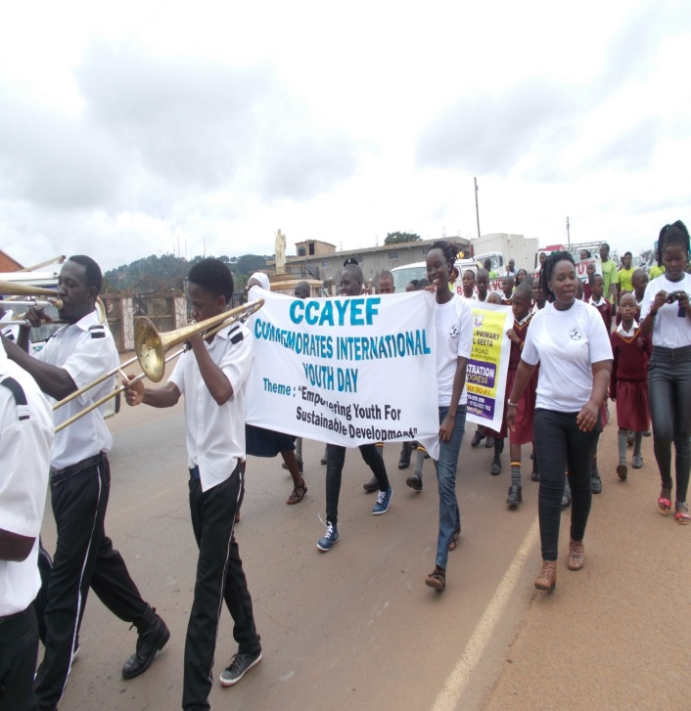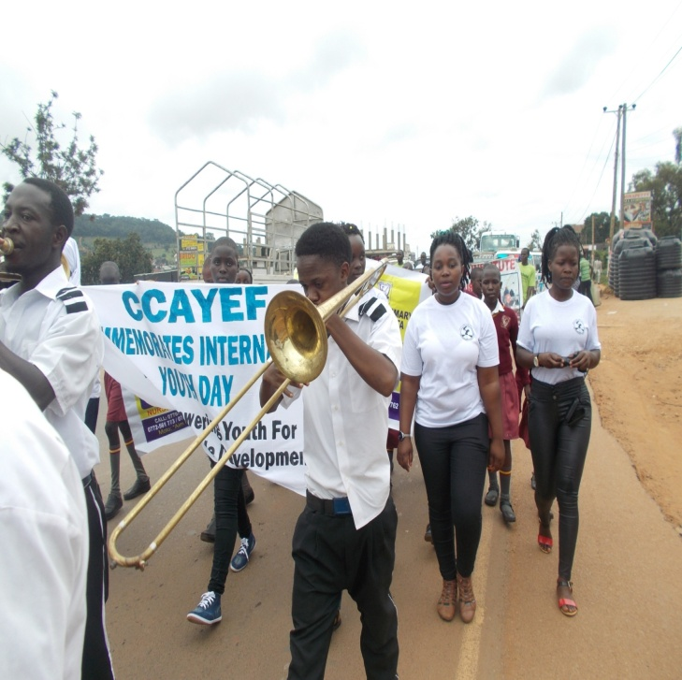

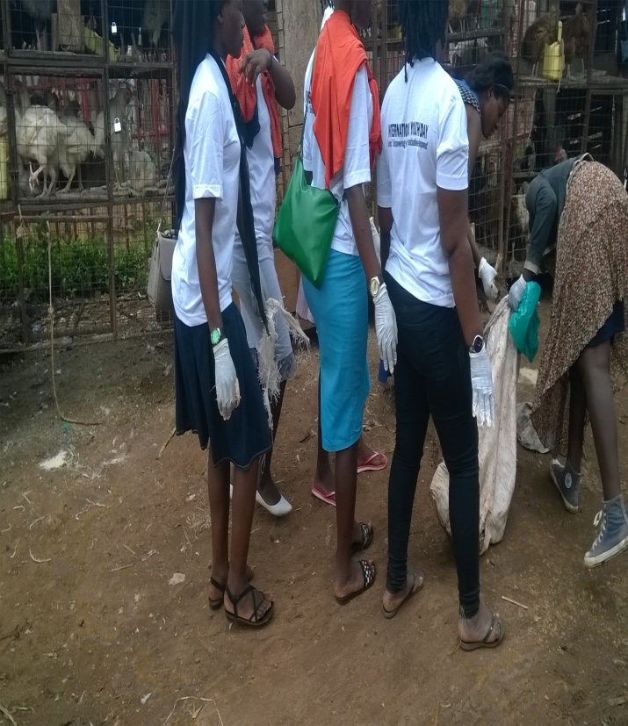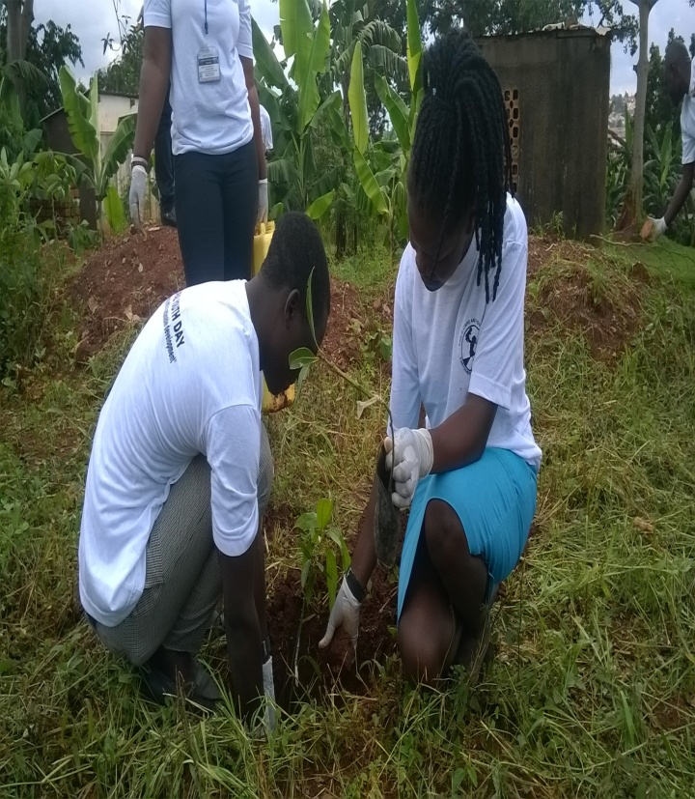

***General cleaning at Kame market Tree planting at Mukono HC IV***

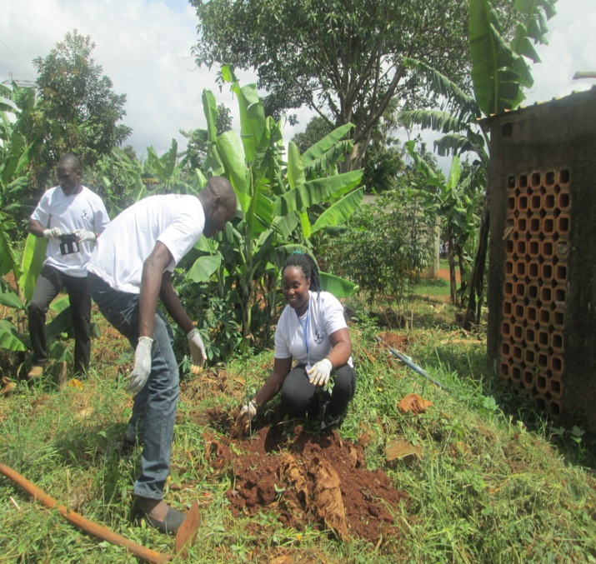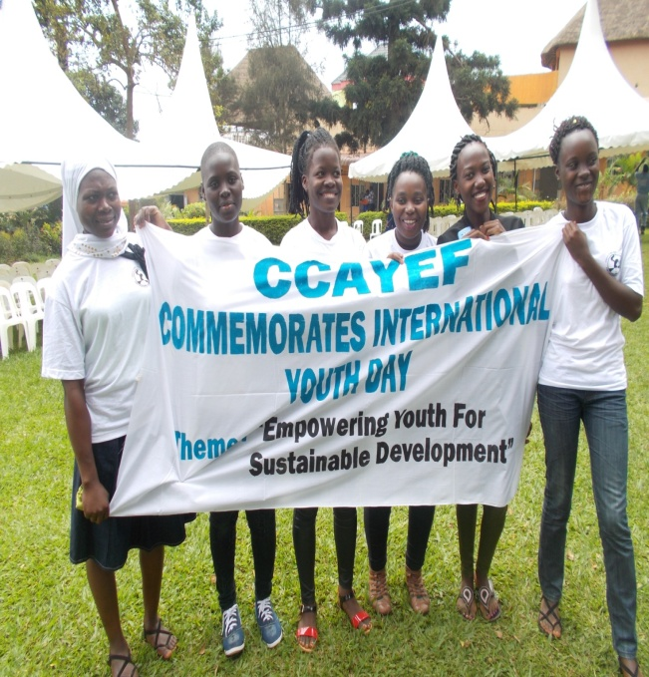

**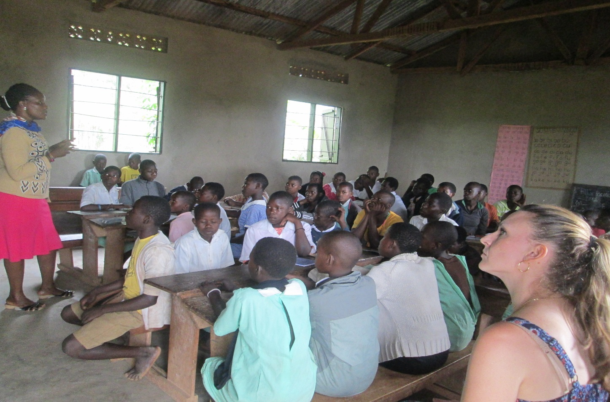**

**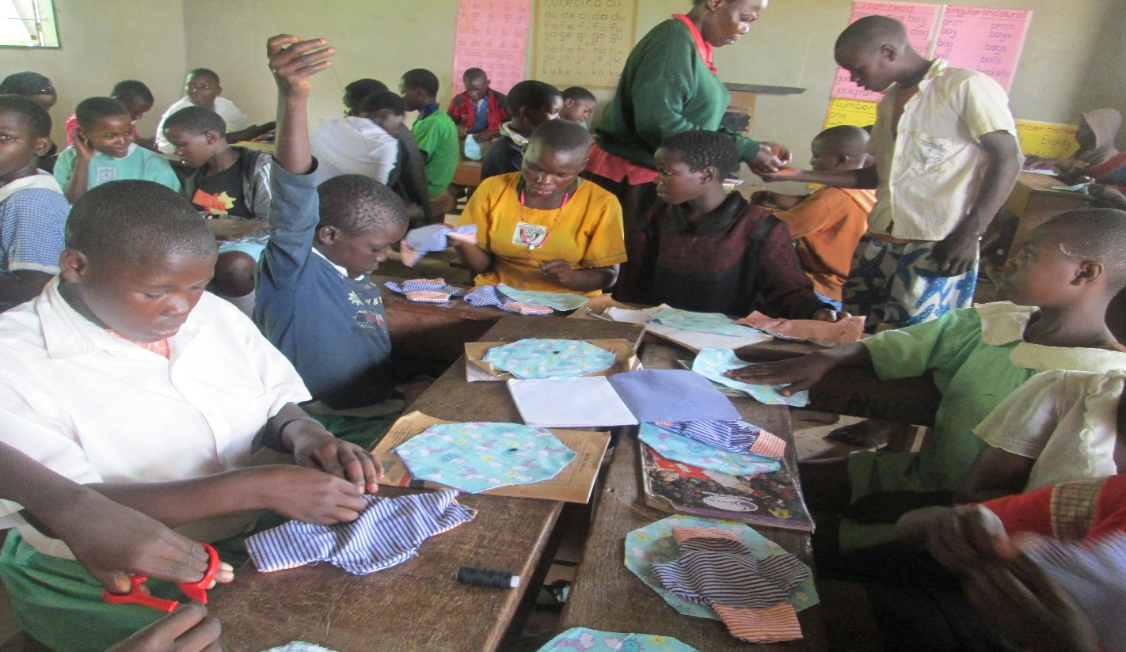*Training of Re-usable sanitary pads at Namutambi P/S***

**PROGRAMME AREA 2: CHILD HEALTH, EDUCATION AND PROTECTION**

Strategic objective for this Program area is to enhance the right to health of 10,000 children below 5-18 years through improved household; nutrition, education, sanitation, hygiene, income levels, and prevention of child abuse and neglect.

Under this program area, several activities are carried out targeting Orphans and other Vulnerable Children including Psychosocial support and Family counseling outreaches; Early Childhood Development activities; Child school Sponsorship; Training in Backyard gardening methodologies; provision of medical care to severely sick babies; information on nutrition and nutritional boosters; advocating for child rights and protection; and offering positive parenting lessons and training to parents.

**Accomplishments**

**Psychosocial support and Family counseling outreaches:**

This intervention targets children between 0-18 years both in and out of school. The entry point of such children and their families is usually attendance of parenting sessions also called SINOVUYO and HIV testing and counseling. This procedure is followed by vulnerability status assessment in areas of Economic strength, Food and nutrition security, Health, Water and sanitation, Child protection and legal support. The results of the assessment inform the next step carried out to address the vulnerability levels. Home visits are carried; house hold development plans are drawn; care givers and grown up girls are then trained in backyard gardening methodology; they are given routine support supervisions and follow up to check on progress. These families and all OVCs are also always linked to access services like ART, VSLA and GBV support and counseling. In this this quarter, 150 households were visited and 150 development plans were developed.

A photo for the jigger’s family (success story)

BEFORE INTERVENTION

Nambogo Sarah

‘’My family members and I used to suffer from jiggers and we also had a problem of bedbugs due to poor sanitation and lack of enough money to buy pesticides’’. Sarah explains. We became stuck and lost hope but after a while CCAYEF recruited our household onto the OVC program, they provided us with pesticides which we used to spray our house and sensitized us on proper hygiene and sanitation”. We no longer have bedbugs and jiggers in our home”. Thanks to CCAYEF.

We shall continue practicing proper hygienic practices in our home to prevent bedbugs and jiggers from our home forever.

Picture for a household development plan

Picture for home visits/ counseling session/ a copy of any development plan that was drawn

The Early Childhood Development Activities:

Early reading and development is a very important milestone for the under 5 children, especially for those children born to adolescent mothers and young women. As these mothers get empowered, they need space where their children can be taken care of. In CCAYEF, these children are taken care of in our ECD Center, where their reading/ talking/ behavior and nutrition are taken care of. This center accommodates almost 50 children 1month-5years. Some of these babies especially those of 3 years are then enrolled into our on-site Kindergarten.

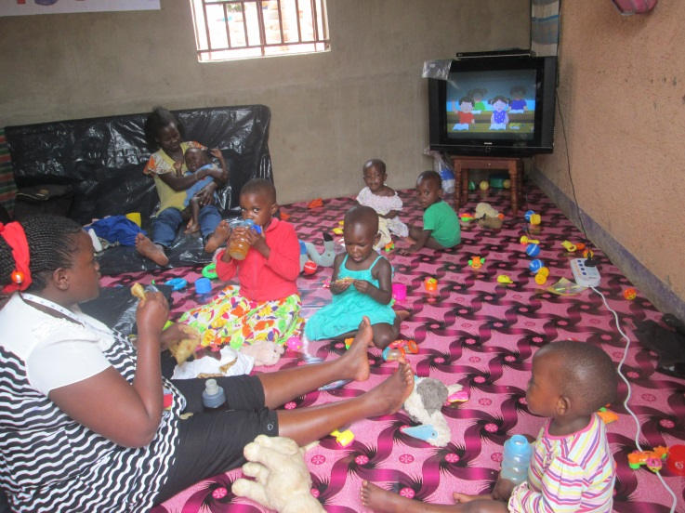

Children playing in the ECD Centre

Child Care Nursery school

Photos of the ECD centre here

**Positive Parenting and Nutritional Classes for parents:**

Every OVC’s family and even teenage mothers and even other vulnerable girls are trained positive parenting sessions. This is intended to support the families re-establish positive relationships with their children and decrease on the cases of domestic violence and child abuse. In turn, this would help children develop trust in their parents/ families and hence, reduced cases of promiscuity/teenage pregnancies and HIV/AIDS infections 250 parents/caretakers and 945 vulnerable adolescent girls and teenage mothers received parenting sessions 53 % of these reported great changes after the sessions. **Indicate number of parents and adolescent girls attending SINOVUYO CLASSES**

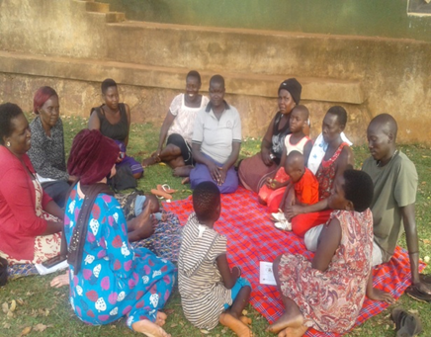

Put a testimony, a photo of SINOVUYO classes- **Another photo is needed here**

***Nnaalinnya Jackie***

***Me, Jackie, 16 years old, dropped out of school after the death of my father because my caretakers were unable to raise money for school fees. CCAYEF recruited me and took and through positive parenting classes where I learnt how to establish a healthy relationship with my care takers and other people. Before, I used to disrespect to my caretakers and also respond to them inappropriately. “Am now respectful and able to respond appropriately to my care takers! Thanks to CCAYEF.***

***I will reach my peers with the information acquired through positive parenting classes to enable them live amicably with their caretakers and other people.***

***MORE SUCCESS STORIES***

**Provision of Nutritional supplements Nutritional training sessions:**

As it is known that children of adolescent mothers find trouble in their proper growth and development due to the age of their mothers and abandonment of responsibility of their fathers, it is not very uncommon to find them under-nourished and at some point malnourished! CCAYEF decided to empower them on feeding methods and trainings through nutritional classes held on a monthly basis for sustainability.

Photo for food

***Girls that received soya flour for their babies to boost their nutritional levels***

* A total number of 40 young mothers underwent training in baby food demonstration (Ekitoobero) preparation classes. Of these, ---- girls have reported improvement of their babies’ nutritional health in terms of weight gain and good appearance.

**Testimony for food demonstration**

***“My baby (1 ½ years) rarely falls sick and his appearance is also good. This is due to food preparation demonstration sessions by CCAYEF where I learnt different food stuffs (enkejje, mukene & ground nuts mixed together) with matooke to feed my baby with,” Mariam explains.***

***“Before the training, my baby used to fall sick very often due to poor feeding and she was almost becoming malnourished! If it wasn’t CCAYEF, by now my baby would be malnourished. Am so grateful”!***

***“I will continue to feed my baby with that nutritious foods to ensure his proper growth and development!”***

**Another testimony from one of the girls and photos**

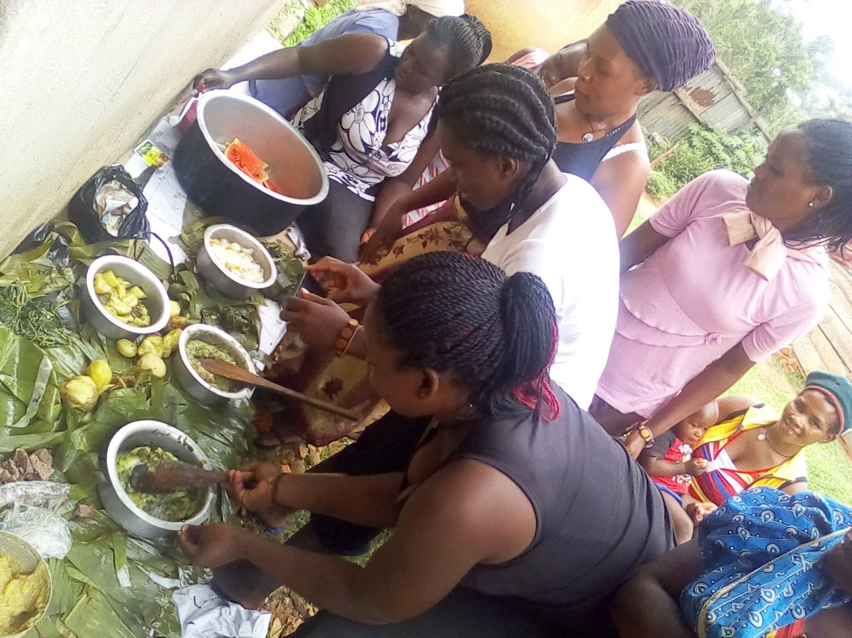

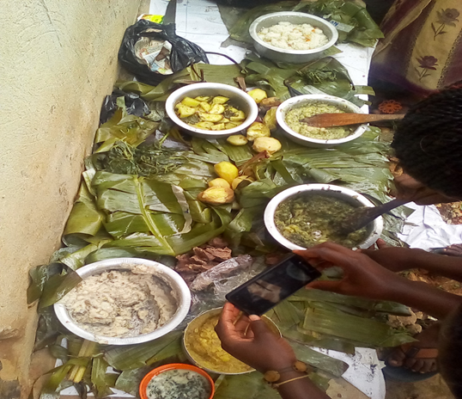 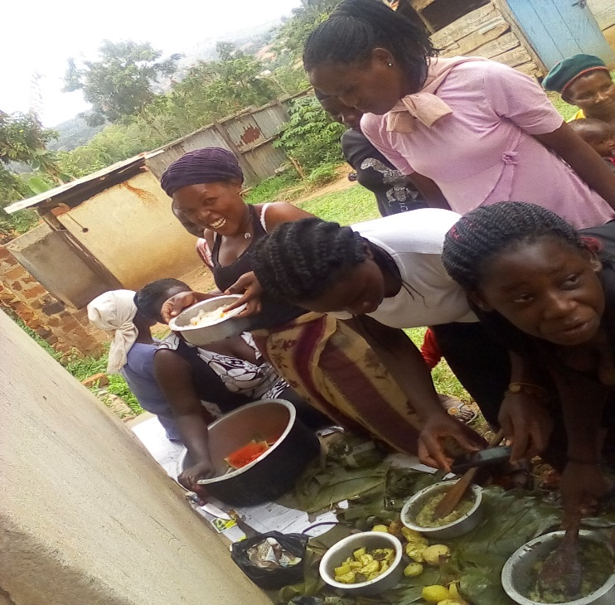

**The Child Sponsorship Program and Conditional Cash Transfers:**

Due to the vulnerability of babies born to adolescent girls, sometimes it proves very difficult for them to attend school, therefore for those who prove to be very vulnerable are sponsored into school at kindergarten and Primary school levels on condition that their mothers are enrolled into the empowerment program and after one and a half years, they will be able to support their children. This does not only work on children born to adolescent mothers, but also to other very vulnerable children under 13 years of age. For the year under review, 153 children were sponsored into school with school fees and other scholastic materials.

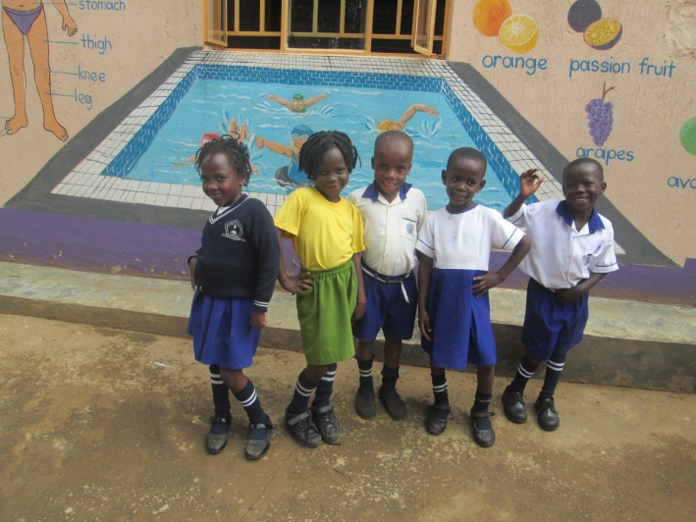 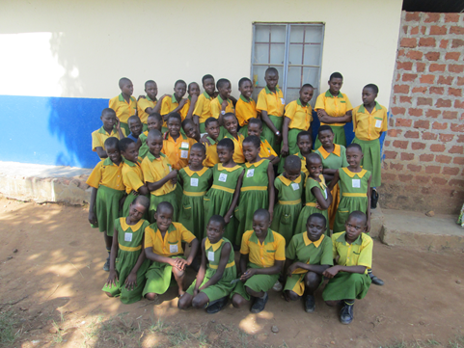Beneficiaries for Child care Nursery school Beneficiaries for Lweza p/s

***Some of the sponsored children in Child Care Nursery school***

***Report card for primary and secondary***

***Report card for Bulya Faustar***

***A report card for Tumusiime Juliana. She was promoted to S.2.***

Photos of other children sponsored/ a photo of report cards for last term/ or receipt of payment is needed here

**Backyard Farming Methodology:**

Girls and their families are trained in Backyard gardening to address issues of malnutrition for their babies and to boost their family incomes when they sell off the surplus. 5 homes out of the --- homes that had gardens established in their homes, are doing well and even earning money out of their gardens while the ---- gardens collapsed due to negligence of the care takers who had higher expectations.

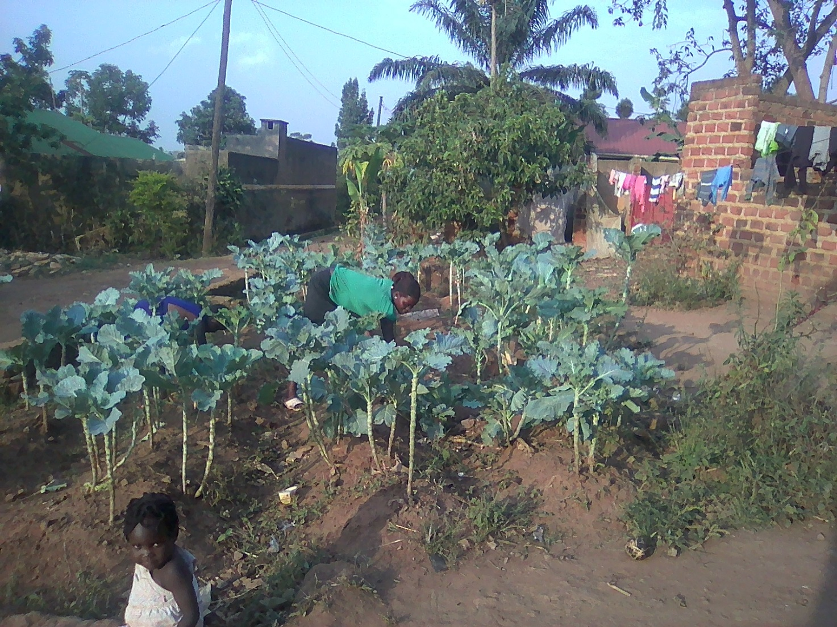

**Back yard garden for Nabayinda Allen’s home**

**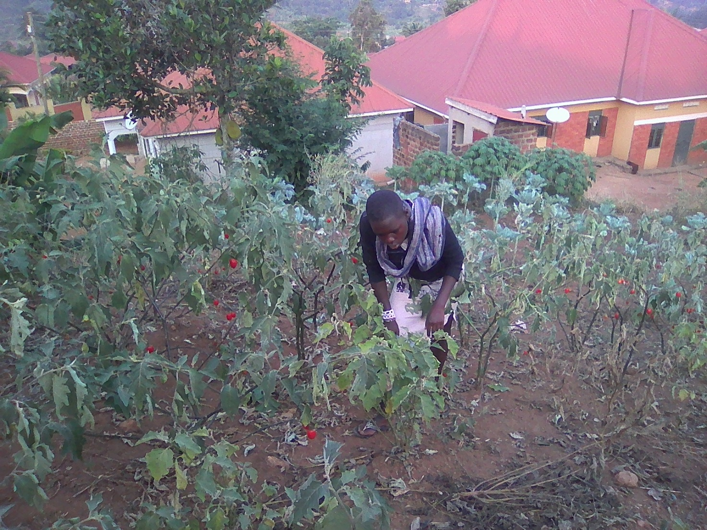**

**Backyard garden for Namakula’s home**

**Testimony**

**Nankinga Cissy the caretaker of Namakula Joyce**

***“We used not to value the issue of eating vegetables at home and would plant a few seedlings for sukuma our chickens.” the care taker for Namakula Joyce explains. “CCAYEF reached our home and trained us in backyard farming and we became aware of the importance of eating vegetables”.***

***We started planting vegetables(sukuma,carrots and african eggplants) on a larger scale for home consumption and for sale.Currently, we are eating vegetables. We sold vegetables worth 40,000/= to people and saved 10,000/= and the balance was used to purchase a rabit.***

***We are gratefull for CCAYEF’s support and we shall continue with the backyard farming to ensure costant supply of vegetables in our home.***

***Another testimony***

**Better photos of backyard are needed here/girls selling their produce/ a testimony**

**Other livelihoods, Treatment and Care for very sick Children:**

It is very common to find children born to adolescent mothers moving around naked and sometimes very sick with no hope of accessing medical care! It therefore the major reason CCAYEF solicits treatment services-in- kind; money and clothing from well-wishers and in turn give out these livelihoods to the most vulnerable but very hardworking babies’ mothers to cloth their children. In this quarter, a total number of 100 babies through their mothers received clothing, treatment and other livelihoods. And for this great thanks go to Mobilemama and Kiwaga Heath Care and St. Paul Catholic Parish Mukono who have donated the above services to all our babies.

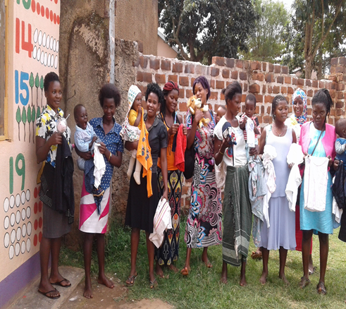

Another photo for girls that received clothes

***Girls that received clothes donated to CCAYEF by Lisa Burgess***

**PROGRAM AREA 3: EARLYMARRIAGE AND PREGNANCY PREVENTION (EMPP)**

The major goal of this Program area is to support pregnant adolescents have health pregnancies/deliveries; become better parents, postpone second pregnancies and take steps to self-sufficiency in Mukono District. It directly targets out of school pregnant adolescents and child brides; and indirectly targets their families of origin; communities, men and adolescent out of school boys, church and cultural leaders in a bid to empower them support these vulnerable adolescents in Mukono District.

The intervention addresses issues of Pregnant Adolescents’ and child brides’ Sexual reproductive health rights and service demands; economic development and empowerment, HIV prevention and care, Life skills training, health and nutrition, behavior change communication programs; psychosocial support to girls and their families; and Economic Strengthening. It also puts into account community mobilization against teenage pregnancy and early marriages.

**What we set out to achieve?**

In the year under review, it was planned to reach out to 280 teenage mothers and child brides with different services, and as discussed below were the achievements, challenges and suggested way forwards submitted under this program area:

During the Recruitment and Assessment exercise, only 9 pregnant adolescents, teenage mothers and child brides were enrolled into the program as opposed to the 70 planned before. This is due to decrease in geographical coverage due to several implementing partners targeting the same population characteristics. Despite the low enrollment, the same girls received all the planned services.

**What was accomplished in 2017!**

* 1. **Risk Reduction and life skills training Classes:**

Under this intervention, three activities are implemented to achieve the best results and these include;

1. **SRHR/Abstinence:**

This is one of our strongest components used in supporting adolescents to avoid unintended second pregnancies, HIV and sexually transmitted diseases (STDs). Pregnant adolescents are urged to abstain from sexual intercourse until they are older. It places emphasis on abstinence, teaching that adolescents younger than 18 are always not yet mature enough to handle the consequences of sexual activity, and therefore, argued to make good use of this second chance. This component employs provision of information or education on benefits of postponing Sexual Involvement, life skills and sexual education to drive its point home. Sexuality education broadly covers a variety of sexuality-related issues, from the growth and development of the human body and reproductive physiology to the development of healthy sexual attitudes and values. Usually girls who undergo these classes tell very many stories on the benefits of abstinence just as Racheal Says **that; Me Resty dropped out of school in P.7 due to pregnancy and was abandoned by the man responsible denied the pregnancy but later on, CCAYEF recruited me through the dreams project and took me through risk reduction classes for 2 months. I acquired knowledge on abstinence and opted for abstinence as the best method to prevent me from getting a second pregnancy.**

1. **Contraception & Family Planning Service Provision:**

Contraceptive education is specific to curricula that discuss methods of contraception, how such methods are used and the effectiveness of each in preventing pregnancy or sexually transmitted infections. In addition, such curricula include information on where adolescents can obtain different contraceptive methods. This component puts emphasis on creating access to contraceptive services among sexually active adolescents, particularly 18 years and above. Teenage mothers are encouraged to choose usage of contraceptives to avoid getting second unintended pregnancies before they are economically empowered to cater for those babies since the men responsible always abandon them. In quarter, ----- received information on family planning methodology and -----received services from Mukono Health Center IV.

1. **Life skills:**

This component is considered very critical to the success of our pregnancy prevention strategies. It consists of activities that help child brides and pregnant adolescents build decision-making skills, set goals for their lives, and learn how to say no to unwanted sex and to negotiate within relationships. It has led to reduced incidences of GBV cases within their relationships hence reduction of new HIV infections.

***Me Resty, used to become upset very first and discriminate against people and my neighbors also disliked me because of my temper. I later joined CCAYEF and I was equipped with life skills that enabled me to learn ways of controlling my temper and also to forgive people.’’ I am able to relate with people freely and to live with them peacefully. ’Thanks to CCAYEF.***

***’’I will teach the same skills to my friends and neighbors to enable them lead a better life!’’***

**Psychosocial support & Family counseling:**

This component includes home visits, family counseling, one-on-one counseling sessions to the pregnant adolescents; sessions to reconcile teenagers with their families, re-settlement and education sessions on positive parenting to the families and care-takers. Since in Uganda when most of the girls get pregnant they are kicked out of their homes and forced into early marriages, this component is so crucial that girls are supported to remain under their parents’ care and support as other intervention empower them into self-reliance. In the year under review, 60 homes were visited, 5 teenage mothers reconciled with their families and 10 families presently support their daughters’ education.

Another photo of home visits

* 1. **Economic Strengthening**

a. **VILLAGE SAVING AND LOANS ASSOCIATION (VSLA) Methodology**

This component helps pregnant adolescents and child brides to learn the Village Saving and Loan Association methodology such that they can nurture their saving culture and have access to loan services to start-up Income Generating Activities (IGAs) after acquiring Vocational skills. They are also taken through Financial literacy sessions to enable them manage their businesses well. When the girls grasp this concept, they are almost financially independent hence having bargaining power over their financial and sexual rights.

It’s a group saving scheme where small group members, mainly teenage pregnant girls and young women are trained on how to start and maintain a group saving culture.

These groups comprise of 15-30 members per group. A group takes a cycle of between 8-12 months saving before sharing out. The VSLA groups are well organized with proper record keeping and each member has their individual passbooks where they can track their savings. It's voluntary and the members are self-selected. The groups are self-managed and have a constitution to which they abide by. In the year under review, a total number of 13 groups have been trained comprising of pregnant adolescents, adolescent mothers, child brides, young women 19-24 years and OVC households groups. Some of the accomplishments of this intervention include;

* **Weekly meetings;** All the thirty groups have maintained to hold sittings every week which has helped them save money worth ------- shillings in all!
* **Weekly contributions:** These are agreed upon contributionstowards the welfare bag by each member. This money is to help members, in case of emergencies they can borrow it and return without interest, and a total amount -------shillings has been raised and at the same time used to support these young people addresses their personal emergencies.

***Success story***

***’’ I used to spend all the money I earned and didn’t want to save but after being trained in saving by CCAYEF through Active Women saving group. I learnt the benefits and started saving. I have so far saved 60,000shs and after completing my course in tailoring and fashion designing, I intend to purchase a sewing machine out of my savings.’’ Sarah explains.***

***I will also continue saving in order to improve on the wellbeing of our family.***

* **Borrowing or accessing loans**: Members are able to borrow money from the VSLA for improving their businesses which they can pay back with an interest. Normally the interest rates and the requirements for borrowing in the VSLA are very minimal compared to formal lending institutions which helps the members profit from the loans and as well afford paying back. The interest is shared amongst the members at the end of the cycle.
* **Financial literacy:** -----girls have been trained in financial literacy which involvestraining of members in different skills like business skills, negotiation skills, debt management, saving management, bank linkage, project Identification and project proposal writing. It is from this training that members are able to write project proposals that are eventually partially or fully funded as group income generating activities through the booster grants.
* **Booster grant**

This activity involves giving out grants to boost the best groups with the already formed businesses. In the previous year, eight (8) groups received top up grants and they are progressing as follows;

Photos for the performance of groups

**Some of the VSLA groups that have accessed booster grants**

**SUCCESS STORY FOR BOOSTER GRANTS**

***Photos***

***Basooka Kwavula with their rental chairs received through booster grants***

* 1. **Vocational Skills Training:**

The out of school pregnant adolescent girls and child brides and any other vulnerable adolescents and young women up to 24 years are given opportunity to choose the vocational skills they want to acquire. Skills available include but not limited to; Tailoring and fashion, Hair dressing and salon, jewelry making, making of bags and crafts, Flower arrangement and decoration; and so many others. This component does not only keep them busy, but empowers them with skills to earn a living and in the long run, they will not need to depend on men for a living and hence prevention of more unwanted pregnancies. In this quarter, ----- were trained in these skills.

Under this activity, AGYW were empowered to reduce the economic vulnerability of their households. In vocational training, young people attend training and study to learn a relevant skill within a specific occupation that they can use to make a living in the future.

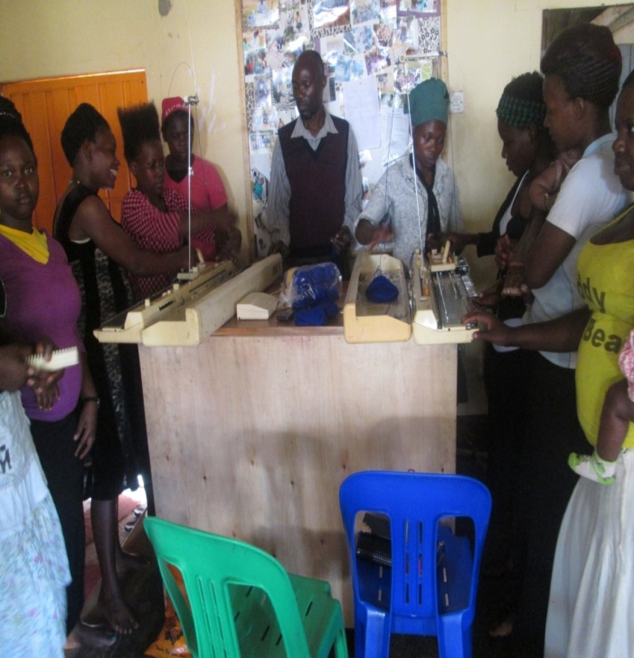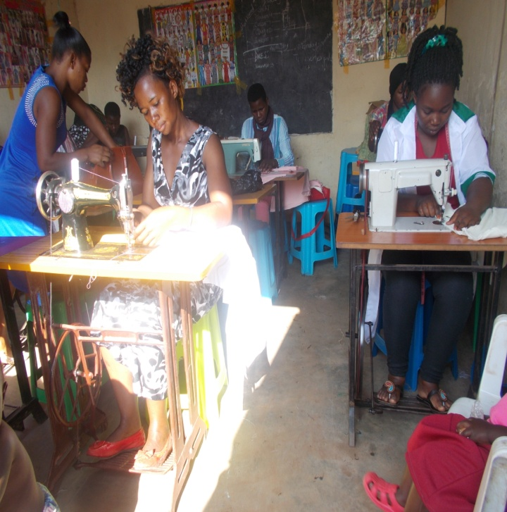

***Students of sweater knitting during training Tailoring class***

More photos for economic strengthening

1. **Re-integration into formal school:**

This involves supporting child brides and pregnant adolescents to re-join formal school and acquire a profession. Conditional cash transfers are released to the girls with a pledge by their families to support them with other scholastic materials, food, shelter and emotional support. Families also pledge to take care of the girls’ babies until that time when they graduate. In the year under review, 3 girls were ushered back into formal school.

|  |  |  |  |
| --- | --- | --- | --- |
|  | **Name of the girl** | **Class of study** | **Highest level of certification** |
| 1. | Nabutono Mercy | 2nd year in Catering at Institute of professional studies-Mukono | Certificate |
| 2. | Asiimwe Gorrette | 2nd year in Business Administration at Institute of Professional studies | Certificate |
| 3. | Nantairo Kruthum | S.5- Green Valley International High School | UCE |

* 1. **Community mobilization and advocacy:**

This component uses men, adolescent boys and all stakeholders in engaging communities to reduce the incidences of teenage pregnancies and child marriages. CCAYEF strongly believes that the involvement of men who are culprits into the teenage pregnancy is a very strong prevention strategy towards solving the latter, according to CCAYEF assessment, business men, builders, boda-boda cyclists, and students are the major culprits when it comes to impregnating teens. Therefore, as focus group discussions go on among teen girls the same is done to men and adolescent boys. Men are also reached through sports activities and religious places. It is from such engagements that advocacy issues are identified and pushed through the local government for consideration. In 2018, 120 male partners of these child mothers were involved in the male dialogues and more are to still be done in the coming year.

* 1. **Peer-to-Peer activities:**

It is all known that adolescents listen to their peers more than they listen to other person when it comes to sexuality issues and hence, the reason our strategy use peers also called ‘Mentor’ to reach out to their fellow peers with rightful information on SRHR/S and other girl issues. This is all done in the ‘safe spaces’ that enable girls to air out all they think is more pressing; some are handled there and then, and others are referred for further management by trustable service points. So far 158 mentors were identified and have supported their peers with information and counseling on issues that would have pushed them into trouble.

**Challenges**

* Inadequate resources to reach more vulnerable girls with trainings in sanitation & hygiene practices.
* ----- gardens failed due to the little interest showed by the care givers for in school OVC in backyard farming because their expectations were more on getting handouts than skills.

**Way forward**

* Mobilizing for resources in order to reach more teenage mothers and other vulnerable girls with our services.
* Lobbying for school fees and scholastic materials for more OVC and other vulnerable children due to the high demand.
* Train more OVC in Back yard gardening and monitoring of existing gardens to check on their progress in order to ensure food and nutrition security in their homes.

**PROGRAM AREA: 4 ORGANISATIONAL CAPACITY STRENGTHENING**

***Strategic objective***

To strengthen Organizational capacity and competences in governance, programming and execution of its mandate.

***Program activities:***

* Mobilize sufficient resources to fund the implementation of organizational activities.
* Improve CCAYEF’s human resource competences in governance, planning and implementation of activities.
* Improve CCAYEF’s office premises, infrastructure and logistics to facilitate effective and efficient service delivery.
* Improve CCAYEF’s Monitoring, Evaluation and reporting systems.

**Below are the details of the activities carried out under this thematic area;**

1. **Improving CCAYEF’s human resource competences in governance, planning and implementation of activities.**

CCAYEF attended the following meetings during this quarter;

***Women’s Day celebrations at Nabbaale sub county headquarters***

***Day for African Child Day at Namakwa P/s***

* Organized a retreat for CCAYEF staff members on 8th /September/2017 at Alvers Hotel-Mukono to improve on interpersonal relationships among staffs and also improve their communication at work for effective service delivery. Presently, employees are able to communicate effectively with one another in the organization and team spirit has also developed.

***CCAYEF staff working groups’ discussions during the retreat***

1. **Improving CCAYEF’s office premises, infrastructure and logistics to facilitate effective and efficient service delivery.**

* .

1. **Mobilizing sufficient resources to fund the implementation of organizational activities.**

**Challenges**

* Inadequate funds to facilitate all the unplanned activities.
* Limited space to effectively carry out all the organization’s activities.
* Unavailability of a room/open space to show case and sell off products made by Adolescent Girls and Young Women from CCAYEF vocational program.
* Submitted a grant application to Skills Development Facility which provides non-repayable funding (matching grants) to organizations that are active in the agribusiness, construction and manufacturing sectors but we were not successful.
* Submitted a proposal on teenage pregnancy prevention and rehabilitation to ANNPCAN but we were not successful.

**Way forward**

* Continue looking for possible funding opportunities to facilitate organizational activities writing proposals, filling grant application forms.
* Designing and printing business cards for marketing CCAYEF products like liquid soap, bags, clothes, shampoo, shoes and jewelry.
* Renting a room/ finding space for showcasing CCAYEF products made by Adolescent Girls and Young Women in the vocational program.
* Continue forming strategic partnerships with more organizations and institutions to increase on CCAYEF’s visibility.